**Assignment 3**

1. Create a scatter plot for Sepal Length, Sepal Width and Petal Length attributes of iris data set (see Note). The value of attribute Petal Length is represented by the size of object in the plot.

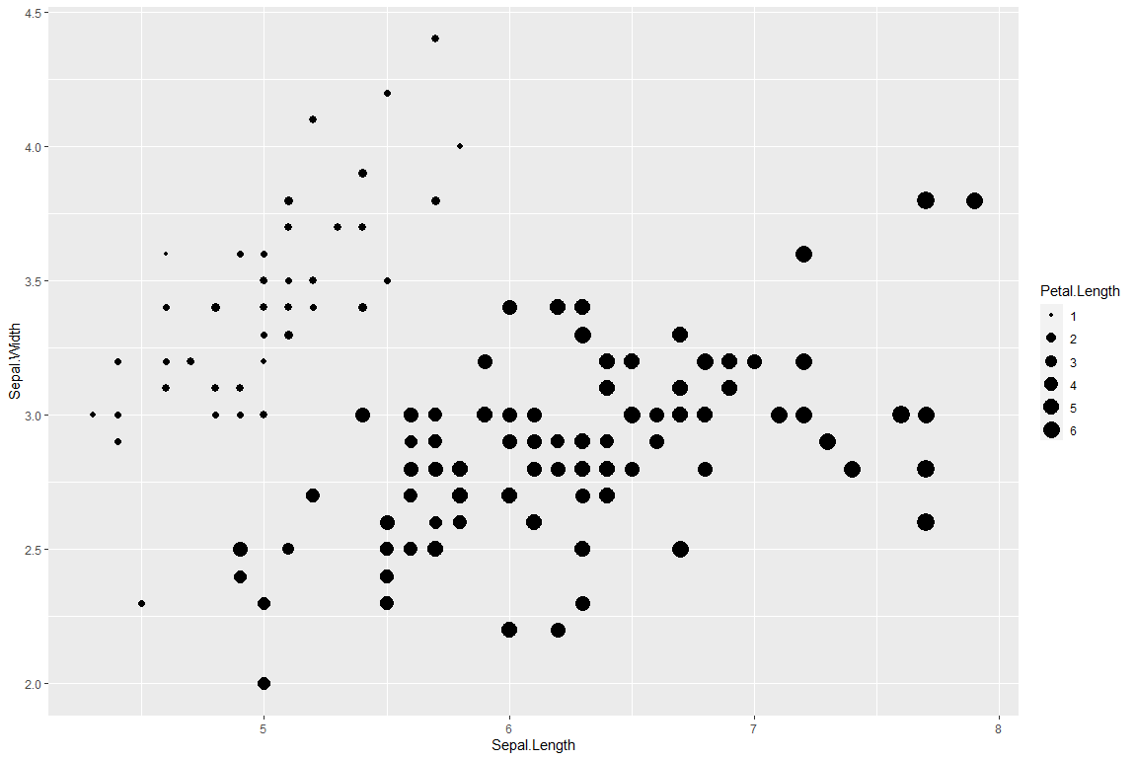

1. Create a scatter plot for Sepal Length, Sepal Width and Species attributes of iris data set. The value of attribute Species is represented by the shape and color of object in the plot.

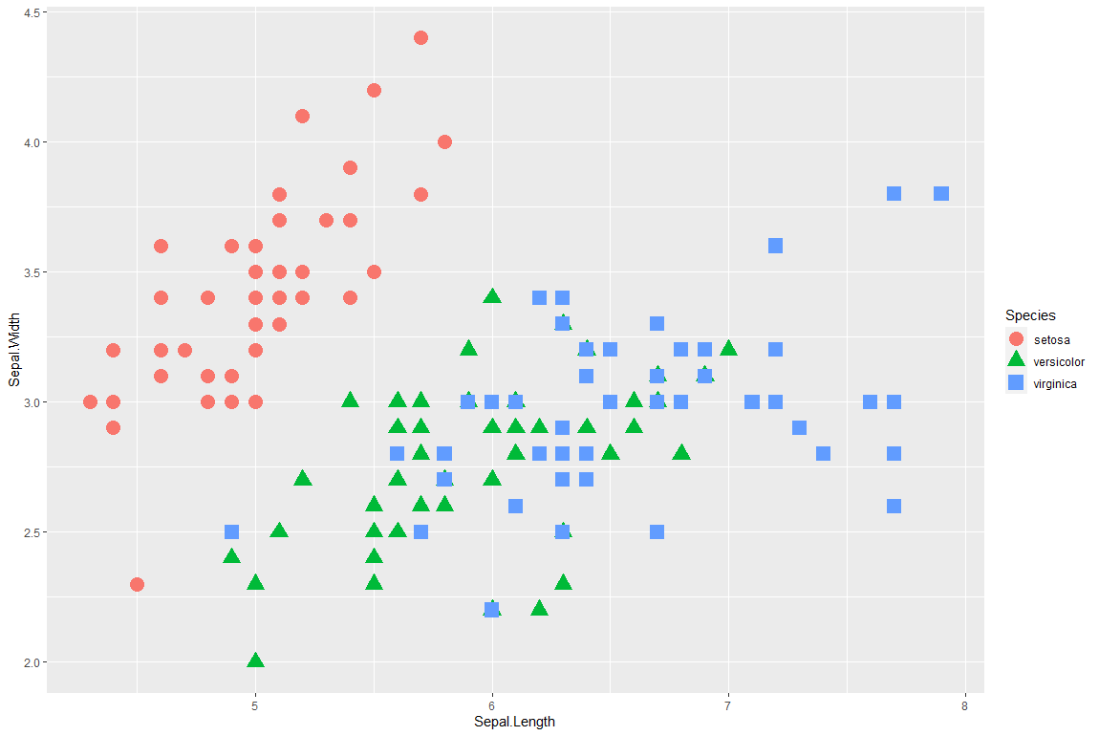

1. Create a 3-dimensional plot for Sepal Length, Sepal Width and Petal Length attributes of iris data set.

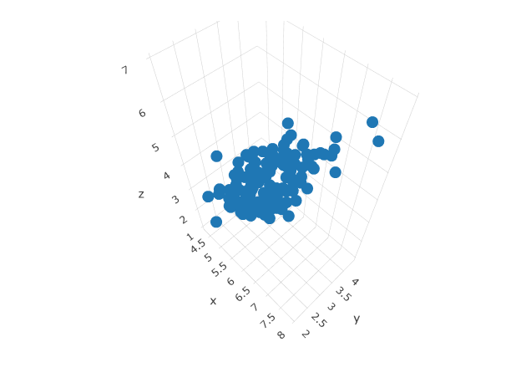

1. Create a parallel coordinate plot for Sepal Length, Sepal Width, Petal Length, and Petal Width attributes of iris data set.

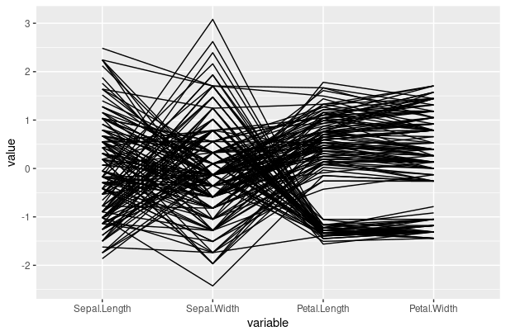

1. Create a star plot for the objects in iris data set with Sepal Length, Sepal Width, Petal Length, and Petal Width attributes.

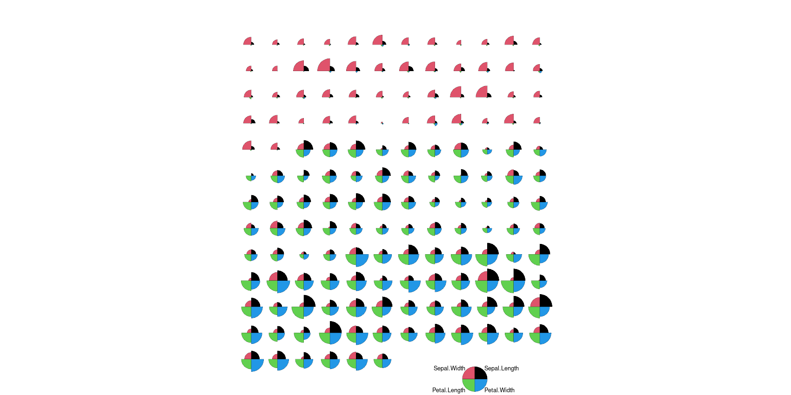

1. Calculate min, max, average, and mode of Sepal Length, Sepal Width, Petal Length, and Petal Width attributes of iris data set.

|  |  |  |  |  |
| --- | --- | --- | --- | --- |
|  | Min | Max | Average | Mode |
| Sepal Length | 4.3 | 7.9 | 5.843333 | 5 |
| Sepal Width | 2 | 4.4 | 3.057333 | 3 |
| Petal Length | 1 | 6.9 | 3.758 | 1.4,1.5 |
| Petal Width | 0.1 | 2.5 | 1.199333 | 0.2 |

1. Calculate amplitude, mean absolute deviation, standard deviation of Sepal Length, Sepal Width, Petal Length, and Petal Width attributes of iris data set.

|  |  |  |  |
| --- | --- | --- | --- |
|  | Amplitude | Mean Absolute Deviation | Standard Deviation |
| Sepal Length | 3.6 | 0.6875556 | 0.8280661 |
| Sepal Width | 2.4 | 0.3367822 | 0.4358663 |
| Petal Length | 5.9 | 1.562747 | 1.765298 |
| Petal Width | 2.4 | 0.6581333 | 0.7622377 |

1. Create a box-plot for Sepal Length, Sepal Width, Petal Length, and Petal Width of iris data set.

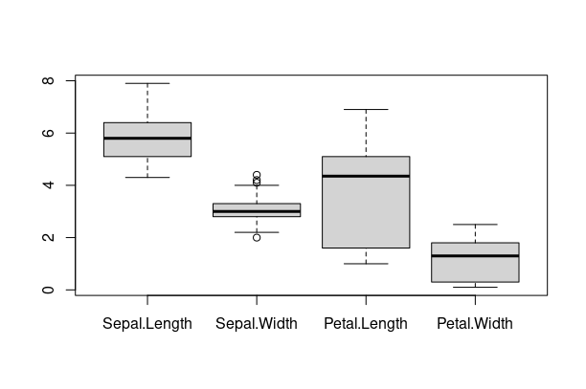

1. Create a scatter plot matrix for Sepal Length, Sepal Width, Petal Length, and Petal Width of iris data set. The plot shows both the scatter plots for each pair of attributes and the corresponding Pearson correlation coefficient.

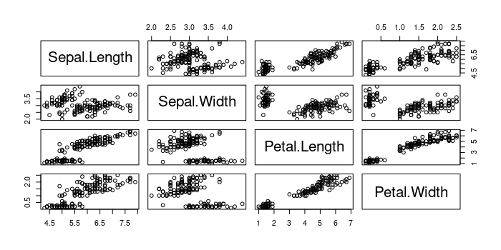

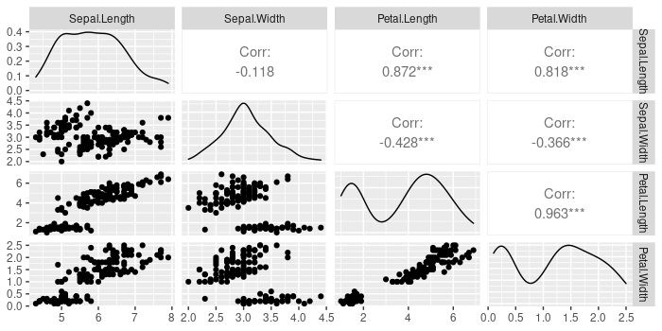

1. Create a heatmap for Sepal Length, Sepal Width, Petal Length, and Petal Width of iris data set.

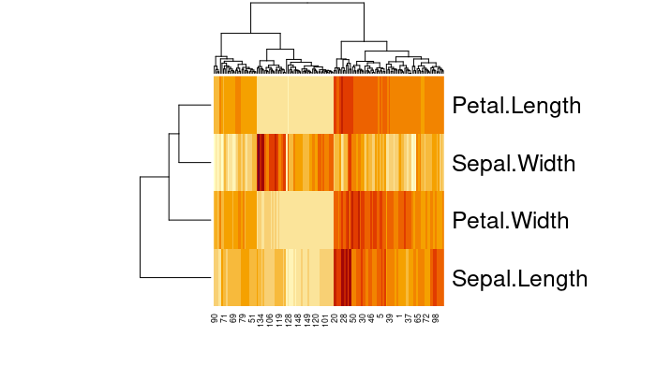

**R Code**

library(plot3D)

library(ggplot2)

library(plotly)

library(GGally)

library(aplpack)

library(corrplot)

library(pheatmap)

nRec <- nrow(iris)

Sepal.Length <- iris[,1]

Sepal.Width <- iris[,2]

Petal.Length <- iris[,3]

Petal.Width <- iris[,4]

Species <- iris[,5]

View(iris)

#1

df <- data.frame(Sepal.Length, Sepal.Width, Petal.Length, Petal.Width,Species)

ggplot(df,aes(x=Sepal.Length,y=Sepal.Width,size=Petal.Length))+geom_point()

#2

ggplot(df,aes(x=Sepal.Length,y=Sepal.Width,group=Species))+

geom_point(aes(shape=Species,color=Species),size=5)

#3

plot_ly(x=Sepal.Length,y=Sepal.Width,z=Petal.Length,type="scatter3d",mode="markers")

#4

ggparcoord(data=df,

columns=1:4)

#5

stars(df, draw.segments = TRUE,col.stars = 1:4, key.loc = c(20, 0.5))

#6

min(Petal.Length)

min(Petal.Width)

min(Sepal.Width)

min(Sepal.Length)

mean(Petal.Length)

mean(Petal.Width)

mean(Sepal.Width)

mean(Sepal.Length)

max(Petal.Length)

max(Petal.Width)

max(Sepal.Width)

max(Sepal.Length)

find_mode <- function(x) {

u <- unique(x)

tab <- tabulate(match(x, u))

u[tab == max(tab)]

}

find_mode(Petal.Length)

find_mode(Petal.Width)

find_mode(Sepal.Width)

find_mode(Sepal.Length)

#7

fun <- function(x)

{

m <- dim(x)[2]

res <- matrix(nrow = 3,ncol = m)

rownames(res) <- c("Amp","mad","sd")

colnames(res) <- colnames(x)

for (i in 1:m)

{

res[1,i] <- max(x[,i])-min(x[,i])

res[2,i] <- mean(abs(x[,i]-mean(x[,i])))

res[3,i] <- sd(x[,i])

}

return(res)

}

fun(iris[-5])

sd(iris$Petal.Length)

sd(iris$Petal.Width)

sd(iris$Sepal.Width)

sd(iris$Sepal.Length)

#8

boxplot(iris[,1:4])

#9

plot(iris[,1:4])

pairs(iris[,1:4])

ggpairs(iris[,1:4])

MP <- cov(iris[,1:4],method ="pearson")

MP

M <- cor(iris[,1:4])

head(round(M,2))

corrplot(M)

ggcorr(iris[,1:4])

#10

irisMatrix <- as.matrix(iris[-5])

irisTransposedMatrix <- t(irisMatrix)[,nrow(irisMatrix):1]

heatmap(irisTransposedMatrix)